Logo Here

Technical Documentation
Date: August 06, 2025, Version: 1.0
Revision History
Version | Date | Author | Description
1.0 | 06-Aug-2025 | xxx | Initial draft

Table of Contents
Technical Documentation 1
1. Introduction 1
1.1 Purpose 1
1.2 Scope 1
1.3 Intended Audience 1
1.4 References 1
1.5 Acronyms and Definitions 1
2. System Overview 2
2.1 High-Level Architecture 2
2.2 System flow - Key Components 2
2.3 User Roles and Access Levels 3
3. Functional Requirements 3
3.1 Module/Feature Name 3
3.2 Inputs/Outputs 4
3.3 Business Rules 4
3.4 Error Handling 5
4. Non-Functional Requirements 5
4.1 Performance 5
4.2 Security 5
4.3 Availability 6
4.4 Maintainability 6
5. Data Model / Database Design 7
5.1 Entity-Relationship Diagram 7
5.2 Tables and Fields 7
5.3 Indexes and Keys 8
5.4 Sample Data 8
6. Integration Points 8
6.1 External Systems 8
6.2 APIs Used 9
6.3 Data Flow Diagram 9
6.4 Authentication/Authorization 9
7. Test Strategy 10
7.1 Test Scenarios 10
7.2 Expected Results 10
7.3 Traceability to Requirements 10
8. Deployment & Configuration 11
8.1 Environments 11
Environment Configuration Parameters 11
8.2 Setup Steps 12
Development (Dev) 12
QA (Quality Assurance) 12
UAT (User Acceptance Testing) 13
Production (Prod) 13
8.3 Configuration Files and Parameters 13
Configuration Files 13
Configuration Parameters 13
Environment Configuration Management 14
9. Appendix 14
Glossary 14
Screenshots 15
Code Snippets 18
References 24

1. Introduction

1.1 Purpose
This document provides the technical design, architecture, implementation details, and deployment information for the AI Service Desk API. It serves as a reference for developers, testers, DevOps engineers, and system administrators involved in the development and maintenance of the application.

1.2 Scope
This document covers:
- System architecture
- API modules
- Database design
- Business logic
- Security implementation
- Testing strategy
- Deployment process
This document does not cover UI implementation or business process documentation.

1.3 Intended Audience
- Developers - To understand the application architecture, API implementation, and database design.
- QA/Testers - To verify the application's functionality and perform testing.
- DevOps Engineers - To deploy, configure, and maintain the application.
- Product Owners -To understand the system features and functionality.

1.4 References
- FastAPI Documentation
- SQLAlchemy Documentation
- Swagger UI Documentation
- Alembic Documentation
- Pydantic Documentation.

1.5 Acronyms and Definitions
- API - Application Programming Interface
- HTTP - Hypertext Transfer Protocol
- JSON - JavaScript Object Notation, a lightweight data exchange format
- CRUD - Create, Read, Update, and Delete operations
- ORM - Object-Relational Mapping, used to interact with databases through objects
- CORS - Cross-Origin Resource Sharing
- Middleware - Software component that processes requests and responses before or after they reach the application
- Dependency Injection - A design pattern used by FastAPI to provide dependencies such as database sessions or services to API endpoints
- UUID - Universally Unique Identifier

2. System Overview

2.1 High-Level Architecture
Client requests are received through REST APIs developed using FastAPI. The application processes requests through the service and repository layers before interacting with the PostgreSQL database using SQLAlchemy.
Architecture Diagram
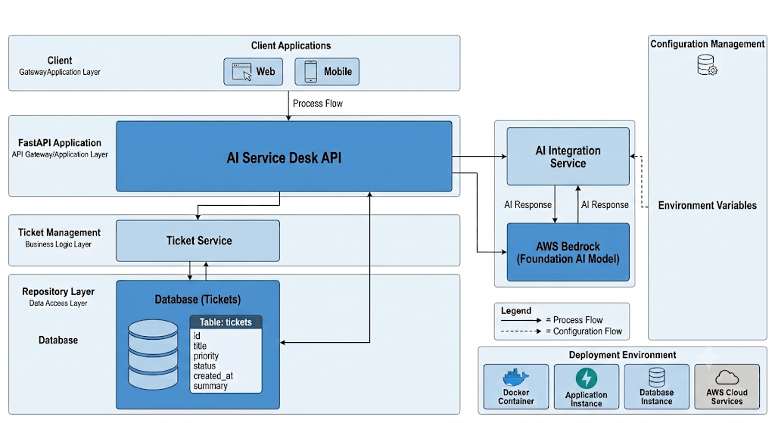

2.2 System flow - Key Components
- Client - Sends an HTTP request to the FastAPI application.
- Middleware - Processes the request (e.g., CORS, response time measurement).
- API Router - Receives the request and routes it to the appropriate endpoint.
- Pydantic Schema - Validates the request data before processing.
- Service Layer - Executes the business logic and coordinates the application workflow.
- Repository Layer - Handles database operations such as creating, retrieving, updating, and deleting records.
- SQLAlchemy ORM - Converts Python objects into SQL queries.
- PostgreSQL Database - Stores and retrieves application data.
- Response - The processed result is returned to the client as a JSON response.

2.3 User Roles and Access Levels
- Developers - View assigned tickets, update ticket status, and resolve tickets and review the tickets.

3. Functional Requirements

3.1 Module/Feature Name
1. Ticket Management
- Allows users to create, view, update, and delete support tickets.
- Stores ticket details such as title, description, priority, status, and email.
- Generates a unique Ticket ID for each request.
2. AI Ticket Summarization
- Uses an AI service to generate a concise summary of the prompt.
- Helps to summarize things quickly.
3. Ticket Search and Filtering
- Allows users to search tickets by Ticket ID.
- Supports filtering tickets based on priority or status.
4. Ticket Status Management
- Enables support engineers to update the status of a ticket (e.g., Open,Closed).
- Tracks the current progress of each support request.
5. Database Management
- Stores and retrieves ticket information using PostgreSQL.
- Maintains data consistency through SQLAlchemy ORM and Alembic migrations.
6. API Documentation
- Provides interactive API documentation using Swagger UI.
- Allows developers to test API endpoints directly from the browser.
7. Middleware
- Handles Cross-Origin Resource Sharing (CORS).
- Measures API response time and includes it in the response headers.
- Processes requests before they reach the application and responses before they are returned to the client.

3.2 Inputs/Outputs

Module / Feature | Input | Output
Create Ticket | Title, Description, Priority, Email | Ticket ID, Success Message, Created Ticket Details ,Status
Get Ticket | Ticket ID | Ticket Details
Get All Tickets | Optional Filters (Priority, Status) | List of Tickets
Update Ticket | Ticket ID, Title, Description, Priority, Status ,email | Updated Ticket Details, Success Message
Delete Ticket | Ticket ID | Success Message
Middleware | HTTP Request | HTTP Response with X-Response Time Header

3.3 Business Rules
Validations
- The ticket title and description are mandatory fields.
- The email address must be provided in a valid format.
- If the priority is not specified, the default priority is set to Low.
- Only predefined priority values (LOW, MEDIUM, HIGH) are accepted.
- Each ticket is assigned a unique Ticket ID using UUID generation.
- A ticket must exist before performing update or delete operations.
- All incoming request data is validated before processing.
- Database transactions are managed to maintain data consistency during failures.
- API responses include the processing time through the X-Response Time header.
- CORS rules are applied to control allowed client access.
Dependencies
- Database Connection
- AWS Bedrock

3.4 Error Handling
- Validation Errors - Invalid request data is handled using Pydantic validation and returns appropriate error messages.
- Resource Not Found Errors - If a requested ticket does not exist, the system returns a 404 Not found response.
- Database Errors - Database exceptions are captured, transactions are rolled back, and errors are logged.
- Authentication Errors - Unauthorized requests return appropriate authentication error responses.
- Internal Server Errors - Unexpected application errors are handled and returned as 500 Internal Server Errors.
- API Error Responses - All errors are returned in a structured JSON format containing error details and status information.
- Transaction Management - Failed database operations are rolled back to maintain data consistency.

4. Non-Functional Requirements

4.1 Performance
- Response Time - API requests should be processed within an average response time of 500 milliseconds under normal conditions.
- Throughput - The system should support multiple simultaneous API requests without significant performance degradation.

4.2 Security
- Input Validation - All incoming requests are validated using Pydantic to prevent invalid or malicious data.
- Authentication → Users are authenticated before accessing protected API endpoints (e.g., using JWT or OAuth2).
- Authorization → Role-Based Access Control (RBAC) ensures users can only perform actions permitted by their assigned roles.
- Data Encryption - Communication between the client and server is secured using HTTPS.
- Database Security - Sensitive configuration details, such as database credentials, are stored securely using environment variables.
- CORS Protection - Cross-Origin Resource Sharing (CORS) policies restrict API access to authorized client applications.
- Error Handling - Internal system errors are not exposed to users, reducing the risk of information leakage.
- Logging and Monitoring - Security-related events and application errors are logged for monitoring and troubleshooting.

4.3 Availability
- System Uptime - The application is expected to achieve 99.9% availability under normal operating conditions.
- Health Monitoring - A health check endpoint is provided to monitor the application's status and ensure it is running correctly.
- Failure Recovery - In the event of an application failure, the service can be restarted to restore normal operation.
- Database Reliability - Database transactions are rolled back automatically if an error occurs, ensuring data consistency.
- Scalability - The application can be deployed on multiple instances behind a load balancer to improve availability and handle increased traffic.
- Backup and Recovery - Regular database backups should be maintained to enable data recovery in case of unexpected failures.

4.4 Maintainability
- Modular Architecture - The application is separated into different layers such as API, Service, Repository, and Database layers.
- Clean Code Structure - Code follows standard practices to improve readability and future maintenance.
- Database Migration - Alembic is used to manage database schema changes safely.
- Configuration Management - Environment-specific configurations are managed using environment variables.
- Error Logging - Application errors and exceptions are logged for easier debugging and troubleshooting.
- API Documentation - Swagger UI provides interactive API documentation for developers and testers.
- Version Control - Source code changes are managed using Git for tracking and collaboration.
- Easy Extension - New features and modules can be added without major changes to existing components.

5. Data Model / Database Design

5.1 Entity-Relationship Diagram
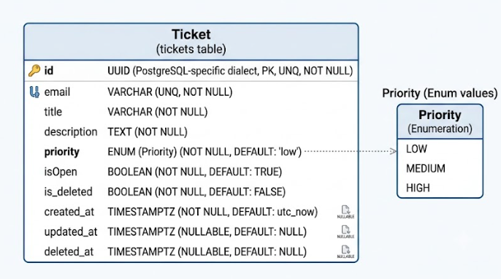

5.2 Tables and Fields

Field Name | Data Type | Description
id | UUID | Unique identifier for each ticket
title | String | Title or subject of the ticket
description | String | Detailed description of the issue
priority | ENUM | Defines ticket priority level (LOW, MEDIUM, HIGH)
email | String | Email address associated with the ticket
isOpen | BOOLEAN | Indicates whether the ticket is open or closed
created_at | TIMESTAMP | Stores ticket creation date and time
updated_at | TIMESTAMP | Stores the last update date and time
is_deleted | TIMESTAMP | Flag for soft delete
deleted_at | TIMESTAMP | Stores the last deleted date and time

5.3 Indexes and Keys
Email - It can be indexed for faster searching

5.4 Sample Data
The following JSON data represents sample ticket records.
{
"id": "8f3b2d91-5c4a-4f12-a8d3-123456789001",
"title": "Login Issue",
"description": "Unable to login into the application",
"priority": "high",
"email": "user1@example.com",
"isOpen": true,
"created_at": "2025-08-06T10:30:00Z",
"updated_at": null,
}

6. Integration Points

6.1 External Systems
- AWS Bedrock (AI Service) - Provides AI capabilities for generating ticket summaries and assisting support operations.
- Swagger UI / OpenAPI - Provides interactive API documentation and allows developers to test API endpoints.

6.2 APIs Used

API Endpoint | Method | Purpose
/tickets/ | POST | Creates a new support ticket with title, description, priority, and email details.
/tickets/get_tickets | GET | Retrieves all available tickets with optional filtering options and also gets specific ticket if ticket id is provided.
/tickets/{ticket_id} | PUT | Updates existing ticket information such as title, description, priority, or status.
/tickets/{ticket_id} | DELETE | Deletes a ticket from the system using the ticket ID.
/ai/summarize | POST | Generates an AI-based summary from the description.
/health | GET | Checks the application health status.
/ready | GET | Checks the application is in ready status.

6.3 Data Flow Diagram
Add or describe a DFD that explains data movement between systems/modules.

6.4 Authentication/Authorization
We don't have Authentication/Authorization in this application

7. Test Strategy

7.1 Test Scenarios
- Verify that a user can create a new ticket with valid input data.
- Verify that ticket creation fails when mandatory fields are missing.
- Verify that users can retrieve ticket details using a valid Ticket ID.
- Verify that the system handles requests for non-existing tickets correctly.
- Verify that all tickets can be retrieved successfully.
- Verify that tickets can be filtered based on priority and status.
- Verify that users can update existing ticket information.
- Verify that users can delete tickets successfully.
- Verify that AI ticket summarization generates a proper summary from ticket descriptions.
- Verify that database operations such as insert, update, and fetch work correctly.
- Verify that invalid API requests return proper validation errors.
- Verify that CORS configuration allows requests from permitted origins.
- Verify that unexpected errors are handled and logged properly.

7.2 Expected Results
- A new ticket should be created successfully when valid ticket details are provided.
- The system should return validation errors when mandatory fields are missing or invalid data is entered.
- Ticket details should be retrieved successfully using a valid Ticket ID.
- The system should return a 404 Not Found response when the requested ticket does not exist.
- The system should display a list of all available tickets successfully.
- Ticket filtering should return only the tickets matching the selected priority or status.
- Existing ticket information should be updated successfully with the provided changes.
- The system should delete the selected ticket successfully.
- The AI service should generate a meaningful summary from the provided ticket description.
- Ticket data should be stored and retrieved correctly from the PostgreSQL database.
- Invalid API requests should return proper HTTP status codes and error messages.
- API responses should contain the X-Response Time header with the processing duration.
- Requests from allowed origins should be accepted, and restricted origins should be blocked according to CORS configuration.

7.3 Traceability to Requirements

Test Scenario | Mapped Requirement
Ticket creation testing | Ticket Management Functional Requirement
Ticket input validation testing | Input Validation Functional Requirement
Ticket retrieval testing | Ticket Viewing Functional Requirement
Ticket update testing | Ticket Modification Functional Requirement
Ticket deletion testing | Ticket Deletion Functional Requirement
Ticket filtering testing | Search and Filtering Functional Requirement
AI summary generation testing | AI Ticket Summarization Functional Requirement
Database operation testing | Database Management Functional Requirement
API response time testing | Performance Non-Functional Requirement
Health check testing | Availability Non-Functional Requirement

8. Deployment & Configuration

8.1 Environments
- Development (Dev)
  - Used by developers for coding, debugging, and local testing.
  - Uses development database and configuration values.
  - New features are implemented and tested before moving to QA.
- QA (Quality Assurance)
  - Used for functional testing, API testing, and bug identification.
  - Validates that the application works as expected.
- UAT (User Acceptance Testing)
  - Used by stakeholders to verify business requirements.
  - Ensures the application is ready for production release.
- Production (Prod)
  - Live environment used by end users.
  - Requires high availability, security, monitoring, and stable configurations.

Environment Configuration Parameters
- DATABASE_URL
  - Database connection URL used to connect the FastAPI application with PostgreSQL.
- AWS_REGION
  - Specifies the AWS region for accessing AWS services.
- APP_NAME
  - Defines the application name.
- AWS_ACCESS_KEY_ID
  - AWS access key used for authentication with AWS services.
- AWS_SECRET_ACCESS_KEY
  - AWS secret key used for secure AWS service access.
- AWS_DEMO_MODE
  - Enables demo mode to test AI functionality without actual AWS Bedrock calls.
- DATABASE_READY
  - Indicates whether the database connection is available and ready.
- BEDROCK_MODEL_ID
  - Specifies the AWS Bedrock AI model used for generating ticket summaries.

8.2 Setup Steps

Development (Dev)
- Install Python and required dependencies.
- Clone the application source code from the repository.
- Create and activate a virtual environment.
- Configure environment variables in the .env file.
- Install project dependencies using requirements.txt.
- Configure PostgreSQL database connection.
- Run Alembic migrations to create/update database tables.
- Start the FastAPI application using Uvicorn.
- Verify application health using the health check endpoint.

QA (Quality Assurance)
- Deploy the application build to the QA environment.
- Configure QA-specific environment variables.
- Connect the application with the QA database.
- Run database migrations.
- Execute API and functional test cases.
- Verify logs, API responses, and application behavior.

UAT (User Acceptance Testing)
- Deploy the approved QA build to the UAT environment.
- Configure UAT environment variables.
- Connect with the UAT database.
- Perform user acceptance testing.
- Validate ticket creation, update, deletion, and AI summarization features.
- Obtain stakeholder approval before production deployment.

Production (Prod)
- Deploy the application to the production server/cloud environment.
- Configure production environment variables securely.
- Configure production PostgreSQL database.
- Run database migrations.
- Configure AWS Bedrock access and credentials.
- Enable monitoring and logging.
- Verify application health and API availability.
- Make the application available to end users.

8.3 Configuration Files and Parameters

Configuration Files
- .env
  - Stores environment-specific configuration values.
  - Contains database, AWS, and application settings.
  - Separate .env files should be maintained for Dev, QA, UAT, and Production environments.
- requirements.txt
  - Contains Python package dependencies required to run the application.
- alembic.ini
  - Contains Alembic migration configuration for database schema management.
- config/settings.py
  - Handles application configuration using environment variables.

Configuration Parameters
- DATABASE_URL
  - PostgreSQL database connection string.
  - Different values are used for Dev, QA, UAT, and Production environments.
- AWS_REGION
  - Defines the AWS region for accessing AWS services.
- APP_NAME
  - Specifies the application name.
- AWS_ACCESS_KEY_ID
  - Stores AWS access credentials for authentication.
- AWS_SECRET_ACCESS_KEY
  - Stores AWS secret credentials securely.
- AWS_DEMO_MODE
  - Controls whether the application runs using AWS services or demo/mock mode.
- DATABASE_READY
  - Indicates the availability status of the database connection.
- BEDROCK_MODEL_ID
  - Defines the AWS Bedrock model identifier used for AI operations.

Environment Configuration Management
- Sensitive values should not be stored directly in source code.
- Environment variables should be managed securely using deployment platform secrets.
- Different configuration values should be maintained for each environment.
- Production credentials should have restricted access.

9. Appendix

Glossary
- API (Application Programming Interface)
A set of rules that allows different software systems to communicate with each other.
- REST API
An API architecture that uses HTTP methods such as GET, POST, PUT, and DELETE for communication.
- Middleware
A component that processes requests and responses between the client and application.
- CORS (Cross-Origin Resource Sharing)
A security mechanism that controls access to APIs from different domains.
- SQLAlchemy
A Python ORM (Object Relational Mapping) library used for database operations.
- ORM (Object Relational Mapping)
A technique that allows developers to interact with databases using programming language objects instead of SQL queries.
- AsyncSession
An asynchronous database session used by SQLAlchemy for handling non-blocking database operations.
- Alembic
A database migration tool used to manage database schema changes.
- UUID (Universally Unique Identifier)
A unique identifier used to identify database records.
- Authentication
The process of verifying the identity of a user or system.
- Authorization
The process of determining what actions a user is allowed to perform.
- AWS Bedrock
An AWS service that provides access to foundation AI models for building AI-powered applications.
- Environment Variable
Configuration values stored outside the application code for managing different environments.
- Docker
A platform used to package and run applications inside containers.
- Database Migration
The process of applying changes to the database schema.
- Health Check
An API endpoint used to verify whether the application is running correctly.
- UAT (User Acceptance Testing)
Testing performed by users or stakeholders to verify that the application meets business requirements.

Screenshots
Models
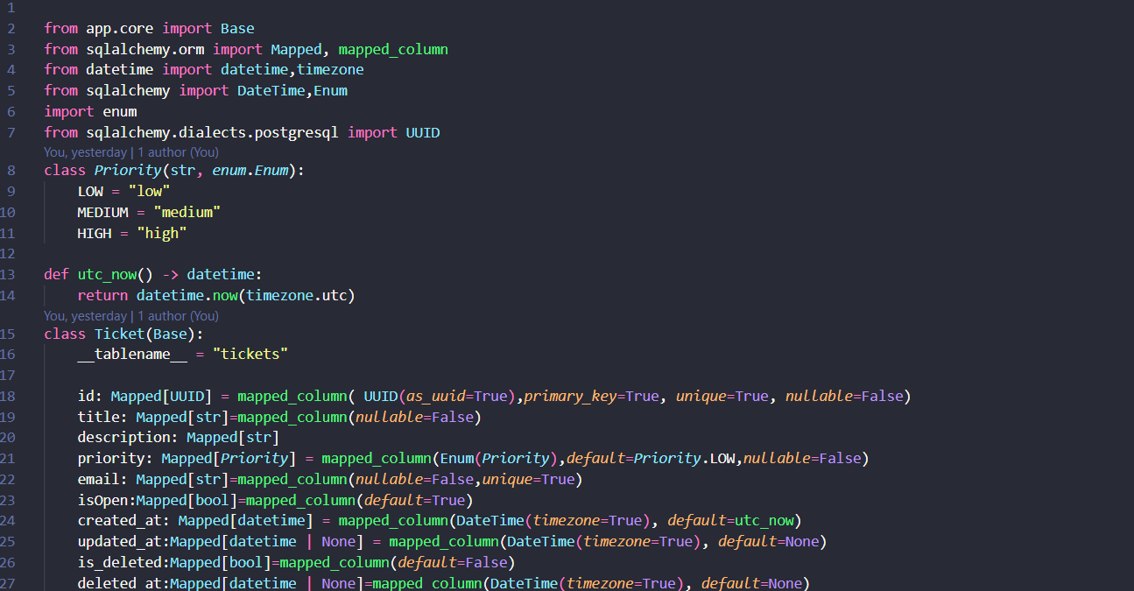
Schemas
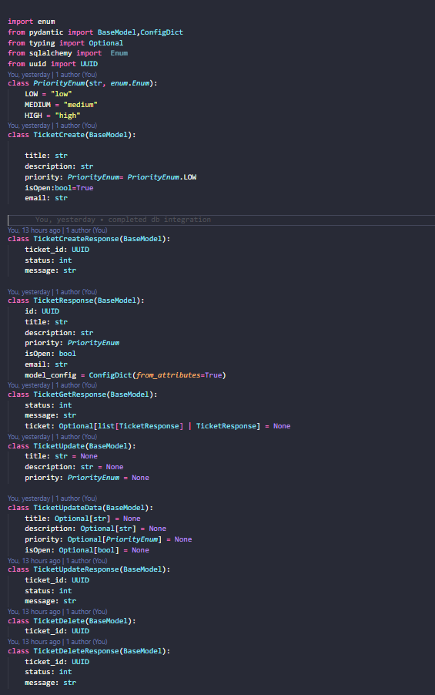

Code Snippets
Service
class TicketService:
def __init__(self, db: Optional[AsyncSession] = None, repo: Optional[Any] = None):
if repo is not None:
self.repo = repo
elif db is not None and not isinstance(db, AsyncSession):
self.repo = db
elif db is not None:
self.repo = TicketRepository(db)
else:
self.repo = None

async def get_ticket(self, ticket_id: Optional[UUID] = None, priority: Optional[str] = None, isOpen: Optional[bool] = None):
if ticket_id:
ticket = await self.repo.get_ticket_by_id(ticket_id, priority, isOpen)
if ticket is None:
raise ValueError("Ticket not found")
if priority is not None and ticket.priority != priority:
raise ValueError("Ticket not found")
if isOpen is not None and ticket.isOpen != isOpen:
raise ValueError("Ticket not found")

return ticket

priority_tickets = []
isOpen_tickets = []

if priority:
priority_tickets = await self.repo.get_all_tickets(priority, isOpen)
if isOpen is not None:
isOpen_tickets = await self.repo.get_all_tickets(priority, isOpen)
if priority and isOpen is not None:
return priority_tickets + isOpen_tickets
if priority and priority_tickets is not None:
return priority_tickets
if isOpen is not None and isOpen_tickets is not None:
return isOpen_tickets
t = await self.repo.get_all_tickets(priority, isOpen)
return t

async def create_ticket(self, ticket_data):
if not ticket_data:
raise ValueError("Ticket data is required")
if not getattr(ticket_data, "title", None) or not str(ticket_data.title).strip():
raise ValueError("Title cannot be empty")
if not getattr(ticket_data, "description", None) or not str(ticket_data.description).strip():
raise ValueError("Description cannot be empty")
if not getattr(ticket_data, "email", None) or not str(ticket_data.email).strip():
raise ValueError("Email cannot be empty")

id = str(uuid())

ticket = Ticket(
id=id,
title=ticket_data.title,
description=ticket_data.description,
priority=ticket_data.priority,
isOpen=ticket_data.isOpen,
email=ticket_data.email
)
created_ticket = await self.repo.create_ticket(ticket)
if created_ticket is None:
raise ValueError("Failed to create ticket")
return created_ticket

async def update_ticket(self, ticket_id, ticket_data):
if not ticket_id:
raise ValueError("Ticket ID is required")
ticket = await self.get_ticket(ticket_id)
if ticket:
updates = ticket_data.model_dump(exclude_unset=True)
updated_ticket = await self.repo.update_ticket(ticket_id, updates)
else:
raise ValueError("Ticket not found")
return updated_ticket

async def delete_ticket(self, ticket_id):
if not ticket_id:
raise ValueError("Ticket ID is required")
ticket = await self.get_ticket(ticket_id)
if not ticket:
raise ValueError("Ticket not found")
else:
deleted = await self.repo.delete_ticket(ticket_id)
if not deleted:
raise ValueError("An Error Occurred")
return deleted

Repository
class TicketRepository:
def __init__(self,db:AsyncSession):
self.db=db
async def get_ticket_by_id(self,ticket_id:UUID,priority:PriorityEnum =None,isOpen:bool| None=None) -> Ticket | None:
q = select(Ticket).where(Ticket.id == ticket_id,Ticket.is_deleted==False)

if priority is not None:
q=q.where(Ticket.priority==priority)
if isOpen is not None:
q=q.where(Ticket.isOpen==isOpen)
result=await self.db.execute(q)
return result.scalar_one_or_none()
async def get_all_tickets(self,priority:PriorityEnum | None,isOpen:bool| None) -> list[Ticket]:
q=select(Ticket).where(Ticket.is_deleted==False)
if priority is not None:
q=q.where(Ticket.priority==priority)
if isOpen is not None:
q=q.where(Ticket.isOpen==isOpen)
result=await self.db.execute(q)
return result.scalars().all()
async def create_ticket(self,ticket:Ticket) -> Ticket:
self.db.add(ticket)
await self.db.flush()
await self.db.refresh(ticket)
return ticket

async def update_ticket(self, ticket_id: UUID,update_data:dict) -> Ticket | None:
ticket = await self.get_ticket_by_id(ticket_id)
if not ticket:
return None
for key, value in update_data.items():
if hasattr(ticket, key):
setattr(ticket, key, value)
ticket.updated_at = datetime.now(timezone.utc)
await self.db.flush()
await self.db.refresh(ticket)
return ticket
async def delete_ticket(self, ticket_id: UUID) -> bool:
ticket = await self.get_ticket_by_id(ticket_id)
if not ticket:
return False
ticket.is_deleted = True
ticket.deleted_at = datetime.now(timezone.utc)
await self.db.flush()
return True

References
- FastAPI Documentation
https://fastapi.tiangolo.com/
Used for API development, routing, middleware, dependency injection, and application configuration.
- SQLAlchemy Documentation
https://docs.sqlalchemy.org/
Used for ORM implementation, database models, and asynchronous database operations.
- Alembic Documentation
https://alembic.sqlalchemy.org/
Used for database schema migration management.
- AWS Bedrock Documentation
https://docs.aws.amazon.com/bedrock/
Used for integrating AI models and generating ticket summaries.
- AWS SDK for Python (Boto3) Documentation
https://boto3.amazonaws.com/v1/documentation/api/latest/index.html
Used for AWS service integration.
- Pydantic Documentation
https://docs.pydantic.dev/
Used for request validation, data models, and application settings management.
- Uvicorn Documentation
https://www.uvicorn.org/
Used for running the FastAPI ASGI application server.
- Docker Documentation
https://docs.docker.com/
Used for containerization and application deployment.

